Hope Hub Facilities Management Group (FMG)

NEWSLETTER February 2018

Who’s who?
Ray Berks
Eon Black
Brian Fleming (Chair)
Jean Gracie
Dave Kitt (Trustee Liaison)
Pat Reid
Mary Whiteford

What’s available?

- Four meeting rooms
Tables, chairs, wallboards and flipcharts are all freely available and rooms can be arranged to many different configurations.

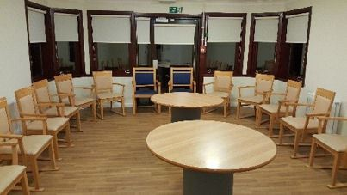

- Auditorium
Up to 200 seats and audio visual equipment available too.

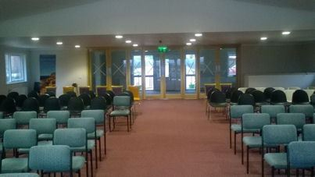

- Newly refurbished toilets/washrooms
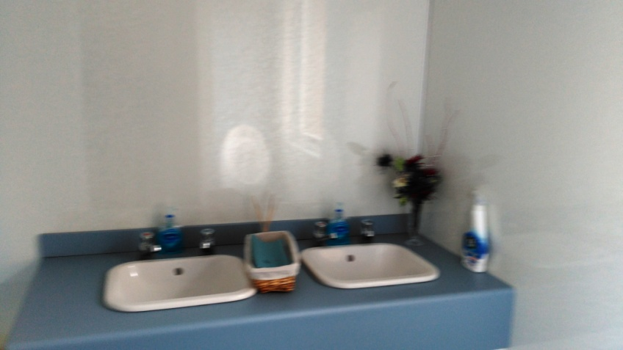
- Communal Kitchen
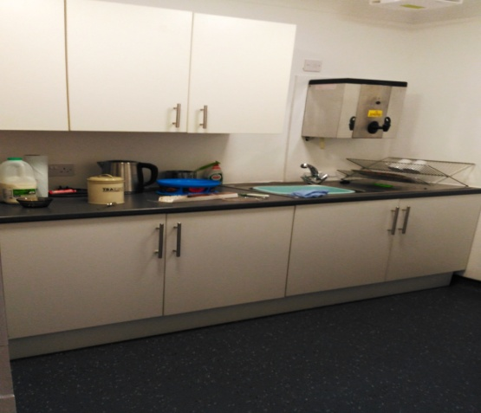

What’s going on at Hope Hub?

- Clydesdale Food Bank
Clydesdale Food Bank has been operational since March 2013.
The Food bank is run by volunteers who give many hours to collecting, sorting, packing and delivering food as well as taking part in various fund raising activities.
As well as the main hub in Carluke, there are satellite distribution sites in Lanark, Biggar, Douglas and Kirkmuirhill, each with their own co-ordinator and team of drivers and deliverers.

- Hope Free Church Breakfast Club
This service is available on Thursday and Friday mornings during term time, for children attending; Blackwood, St John’s and Bent Primary schools.
Breakfast is served between 7.45am and 8.30am. A range of activities are available, until the children are escorted by Walking Bus to their school/school bus. The cost is £2.00 per child per day.

- Velocity Dance Academy

Launched in 2017. Meets every Friday 4pm – 7.30pm.
Innovative Dance Academy for all ages - South Lanarkshire & Glasgow Area.
To find out more information: velocitydanceacademy2017@gmail.com

- In-service day club
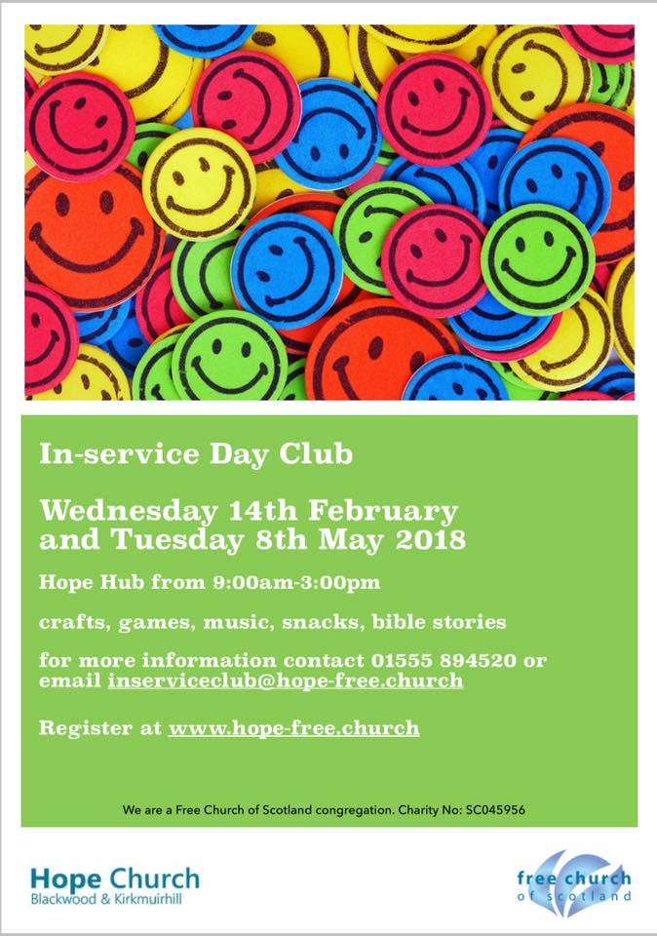

Our next In-service Day Club run by Hope Church Blackwood & Kirkmuirhill will take place at Hope Hub from 9:00am to 3:00pm on Tuesday 8th May 2018 (Lunch will be provided).
All primary school children are welcome. There will be the usual mix of crafts, games, quizzes and Bible stories.
This will be cost free; however registration must be completed prior to children attending the in-service day club and will be limited to the first 50 children to register.

Come Paint With Us - Art Class
Meets on a Tuesday afternoon in one of the meeting rooms and led by Anne Scott.
Members like the rural outlook from the class room, saying “it gave them inspiration!” The class is growing steadily with three new members already in 2018.
All the Classes’ hard work culminated in an art exhibition held at Hope Hub, on Saturday 18th November 2017, where their work was greatly admired.
A visit by Dr. Lisa Cameron MP added something special to the event.
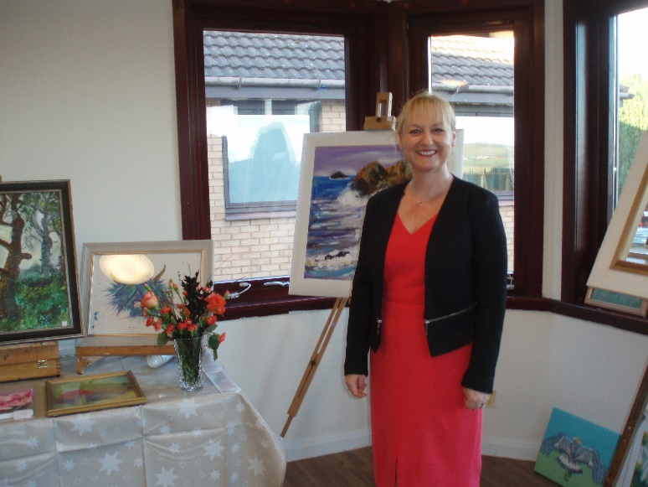

- Blackwood and Kirkmuirhill Playparks Group

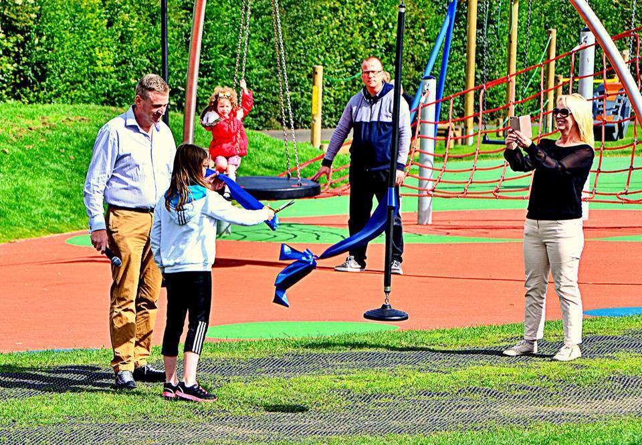

- Community First Responders
Community first responders (CFRs) respond to local emergency calls and provide life saving first aid in those vital minutes before an ambulance arrives.

- Princess Royal Trust Lanarkshire Carers Centre
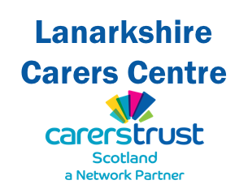
Lanarkshire Carers Centre is a resource for carers across Lanarkshire to access information and a range of direct support services. The centre is based in Hamilton with a second base in Airdrie, supplemented by carer support workers who operate from within locality social work teams across Lanarkshire.
We place carers at the heart of our organisation to ensure the services we offer are effective and accessible, regardless of personal circumstances or caring situations.

Our Vision
"Lanarkshire Carers Centre works with and for carers to develop and deliver services that make a positive difference to the lives of carers in Lanarkshire"
The vision of Lanarkshire Carers Centre is underpinned by a commitment to place carers at the heart of the organisation and ensure that our services are as effective and accessible regardless of personal circumstances or caring situations.

- Alcoholics Anonymous – Third Tradition Wednesday

A new AA Fellowship launching on 28 February 2018 at 8pm and continuing each week at the same time.

- Our calendar is filling up with some organisations making bookings over the entire year.

